COME AND JOIN US!
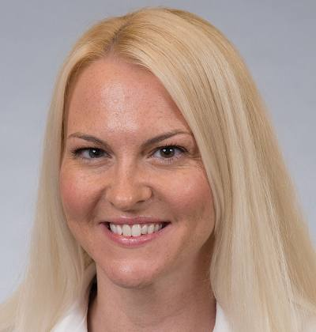

Ochsner North Shore (Covington)
will be hosting a "Walk With A Doc" walk
Nov 11, 2017
Registration 8:00 - 8:30AM @ Coquille Park
WALK TIME 8:30 AM - 9:30 AM
in Covington, LA
http://www.coquillerecreation.com/
Walk with a Doc: Dr. Olga Fermo
Topic for Walk: Medication Overuse Headache

