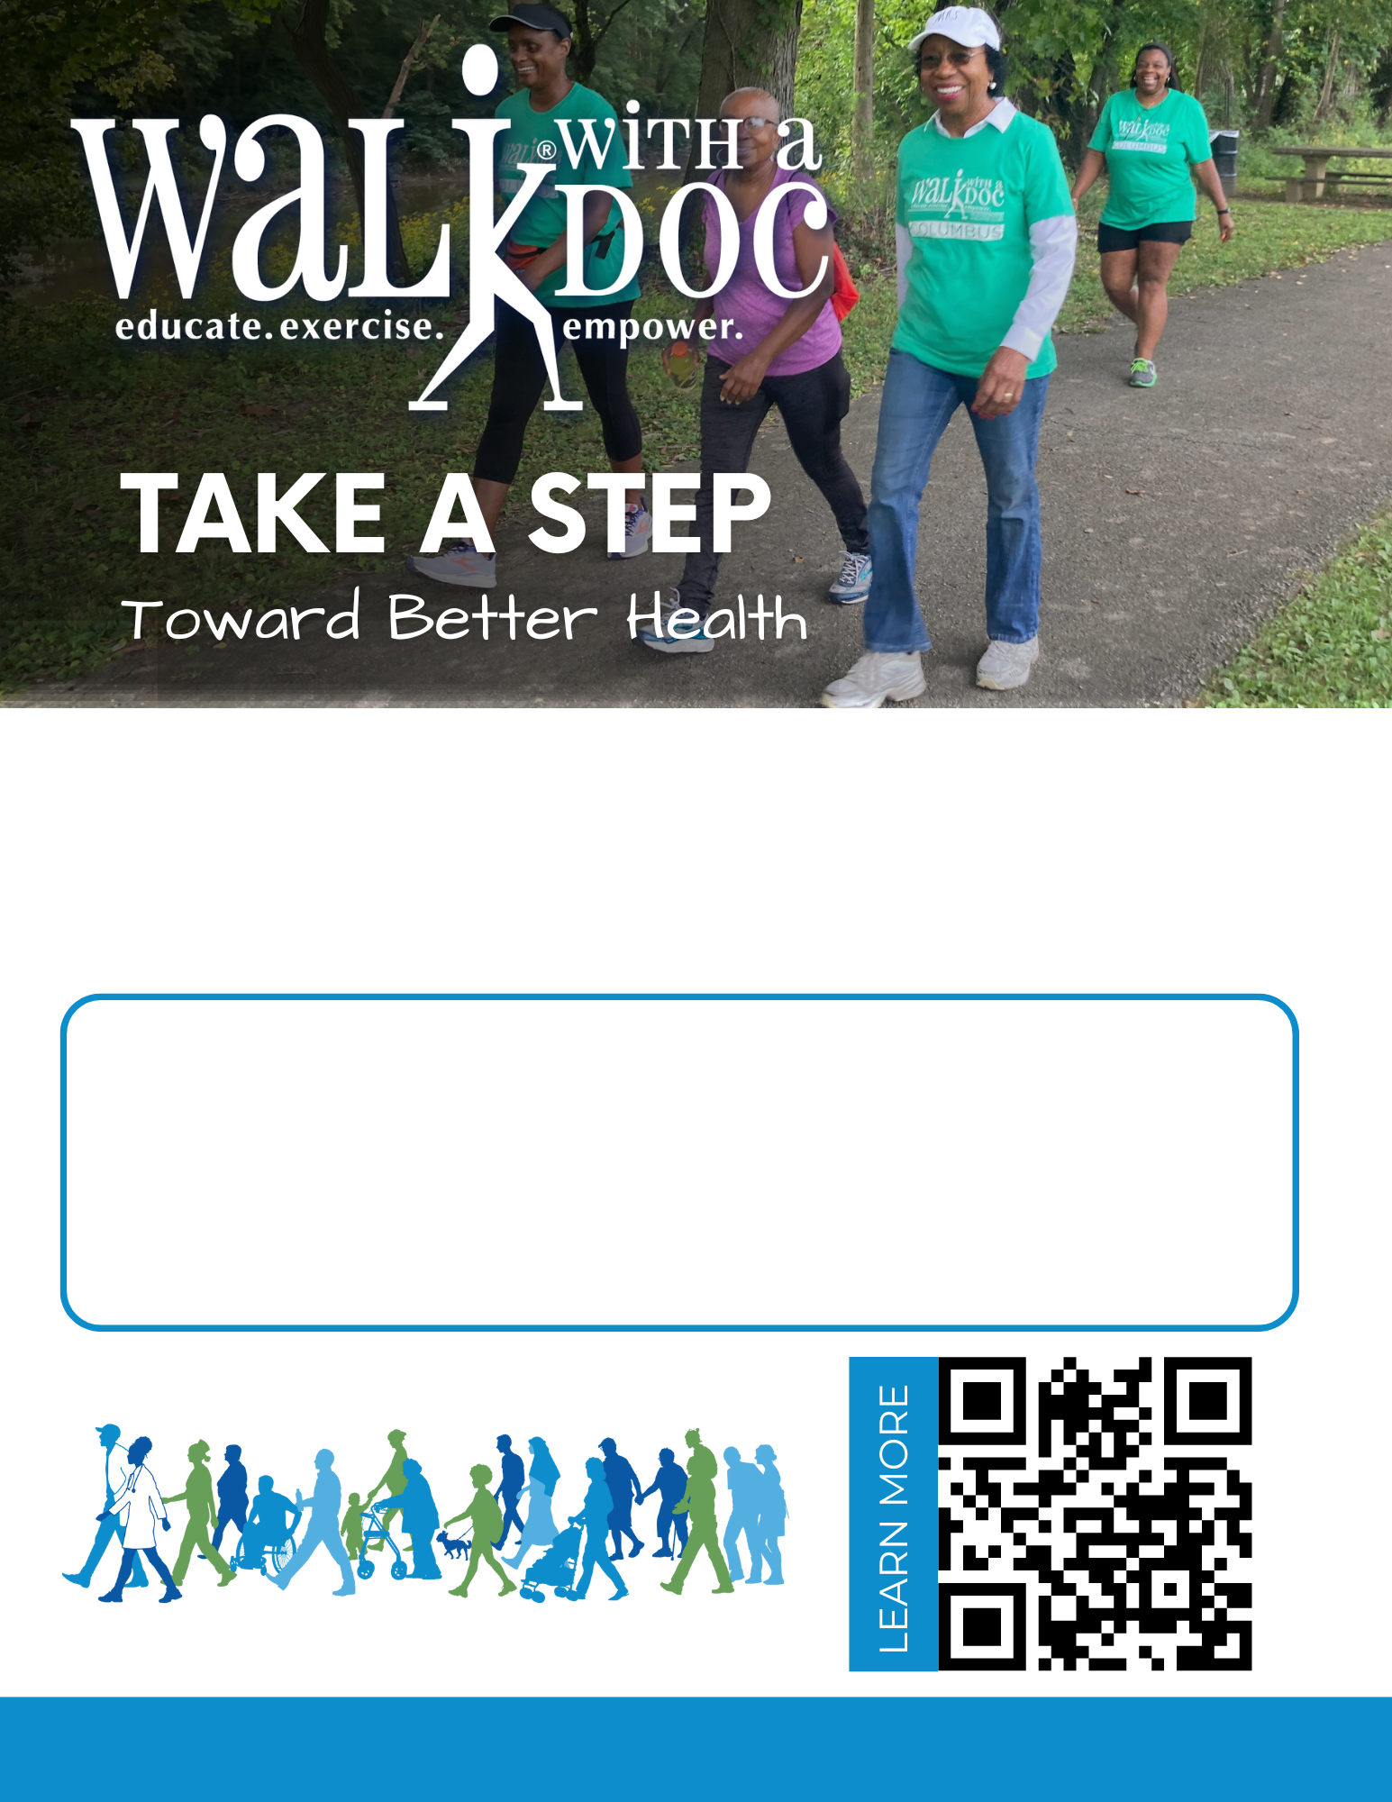
Walking Club: Every Saturday from 9-10 AM
Walk with a Doc: 1st Saturday of every month
Walk Location: Central Park - 123 Main St, New York, NY 12345 (Meet at the fountain)
Walking is one of the best things you can do for your overall health, so join us for a walk! Our walking club meets every week. Once per month, a healthcare provider joins the group to lead a Walk with a Doc event and discuss a health topic.
www.walkwithadoc.org | contact@walkwithadoc.org | 614-714-0407

