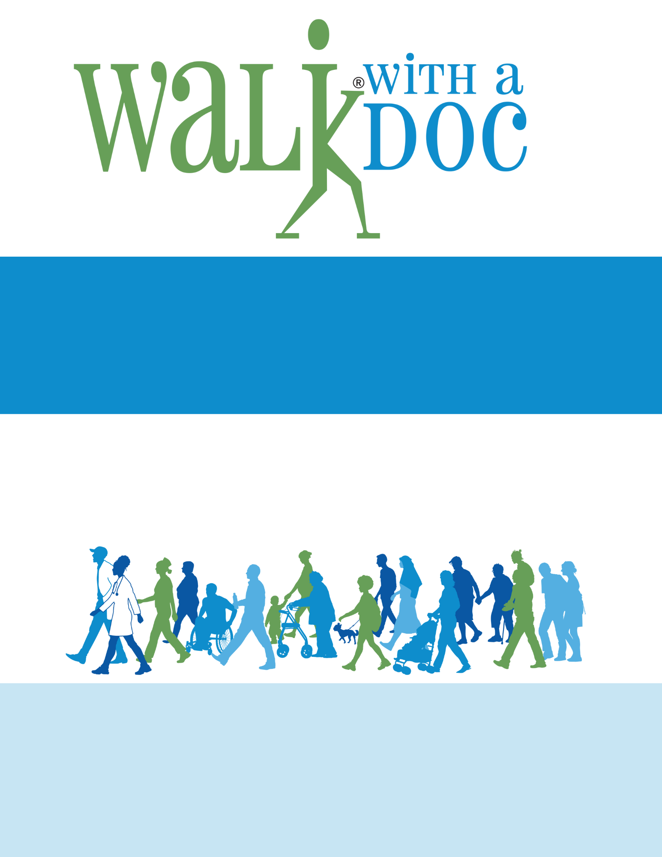

**Saturday, January 1, 2026**

**10:00 – 11:00 AM**

**Central Park- 123 Main St. New York, NY**

**(meet at the fountain)**

This walking program is a fun and safe place to take a walk (at your own pace), learn health tips from local healthcare providers, and meet new friends. The event is FREE and all are welcome!

**Future walks will be held on the 1st Saturday of every month.**

Questions? Email contact@walkwithadoc.org or call (614) 714-0407. We are a local chapter of an international 501(c)3. Scan the QR code or visit **walkwithadoc.org** to learn more.

**Your City**