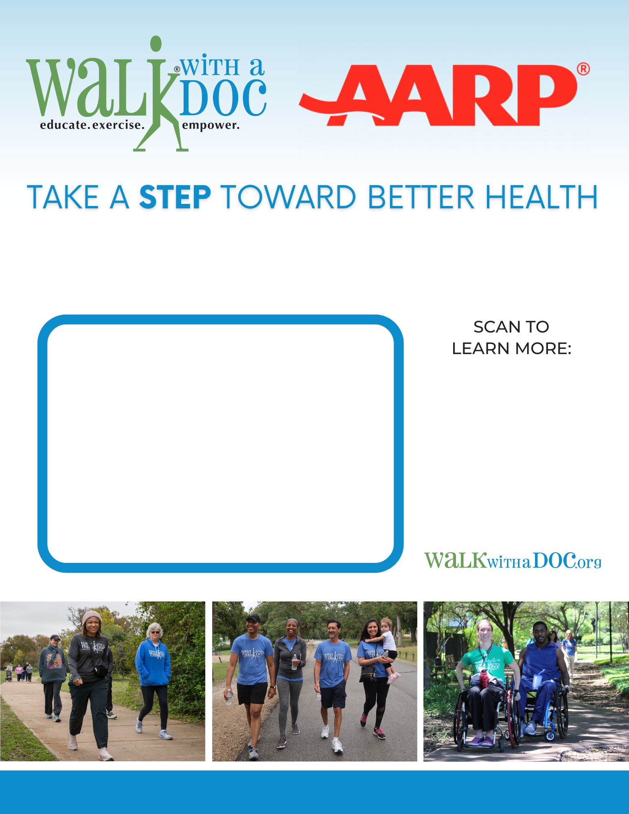

This walking program is a fun and safe place to take a walk (at your own pace), learn health tips from local healthcare professionals, and meet new people. The events are **FREE** and all are welcome!

**Walking on the 1st Saturday of every month at 9:00 AM**

**Walk Location:**

Central Park- 123 Main St. Manhattan, NY

(meet at the fountain)

**Questions?** youremail@email.com (xxx) xxx-xxxx