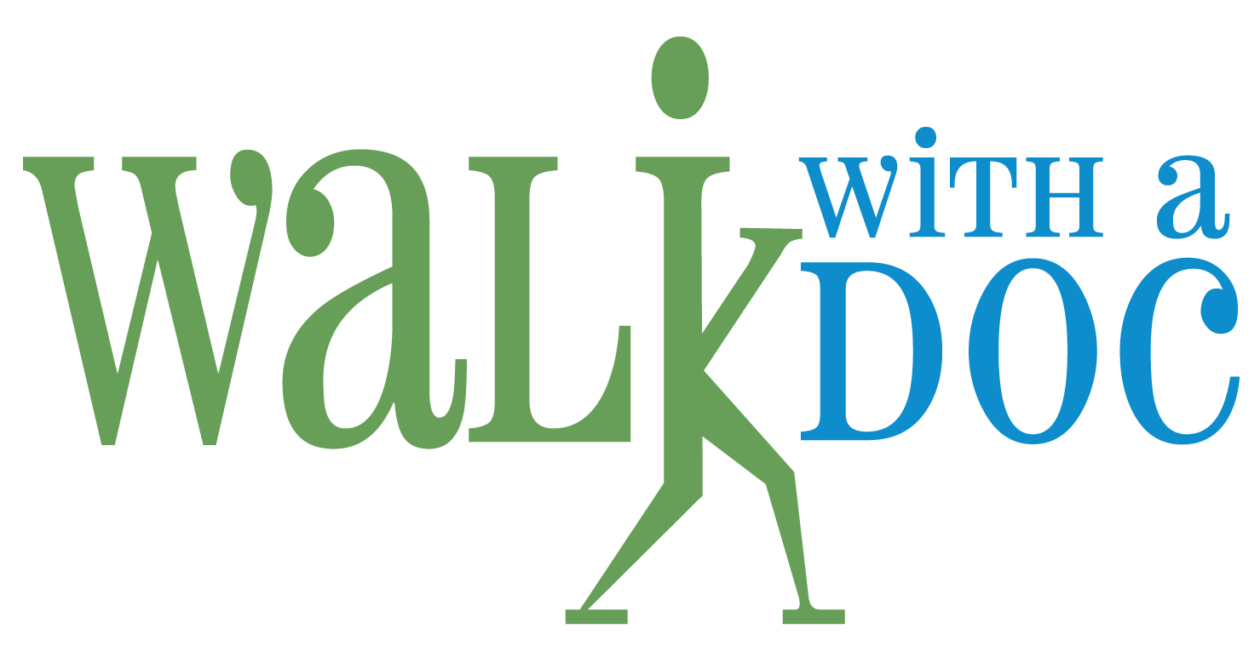

MARKETING AND LICENSING AGREEMENT

This Marketing and License Agreement (this “Agreement”) is entered into as of the date listed on the signature page hereto (the “Effective Date”) by and between Just Walk! Inc., an Ohio non-profit corporation (“Just Walk”), and the entity listed in Section 6 of this Agreement (the “Company”). Just Walk and the Company are sometimes referred to herein collectively as the “parties” or individually as a “party.”

RECITALS:

WHEREAS, Just Walk provides, among other things, free walking programs to encourage healthy physical activity in people of all ages (the “Walking Program”);

WHEREAS, the Company desires to organize a Walking Program in the territory specified in Section 6 (the “Territory”);

WHEREAS, to facilitate the Company in organizing a Walking Program, Just Walk shall provide to the Company a toolkit consisting of a “How-To-Guide;” digital files including logos, forms, signs and templates; promotional materials; a pedometer and t-shirt (the “Toolkit”); and

WHEREAS, the parties desire to enter into this Agreement to set forth the terms and conditions for the Walking Program and certain marketing activities;

NOW, THEREFORE, in consideration of the above premises, the representations, warranties and covenants set forth herein, and for other good and valuable consideration, the receipt and sufficiency of which is hereby acknowledged, and intending to be legally bound hereby, the parties agree as follows:

- Marketing and Promotional Activities. The Company agrees to engage in the following marketing and promotional activities:
- Each Walking Program must include a regular walk (at minimum, monthly) and the participation of either a resident physician actively participating in a residency medical training program, a board-certified physician, or a licensed healthcare provider (in each instance, the “Physician”) at each walk.
- The Physician is encouraged to provide a three to eight minute informational talk prior to each walk.
- The Physician must, at a minimum, commit to a sixty minute commitment for each walk.
- The Company may provide fruit, granola, water and coffee for the participants of each walk, if conducted in a manner consistent with the Company’s safety protocols.
- The Company must display Just Walk’s logo at each walk. Upon request of Just Walk, the Company will also display the names and/or logos of Just Walk's sponsors on walk marketing and promotional materials.
- The Company must be receptive to representatives of Just Walk's sponsors attending the Company’s walks and disseminating sponsor literature.
- The Company must participate as a member in Just Walk’s liability insurance and shall provide notice to Just Walk of the location of the walk to be listed with the insurance carrier. The Company shall not walk at a different location without obtaining prior written approval of Just Walk.
- The Company shall pay a start-up fee of $750.00 to Just Walk. [Additional merchandise is available for purchase.]
- The Company must offer participants in the Walking Program the option to sign-up for the National Just Walk newsletter. The Company shall use its best efforts to register participants to take part in the Walking Program and to obtain executed waivers in the form provided by Just Walk to the Company as part of the registration process.
- The Company shall not through itself or through any third party or entity, including, but not limited to, a physician affiliated with the Company, such physician’s practice, or a health system affiliated with the Company, advertise, promote, sell or distribute any products at any walk unless previously approved in writing by Just Walk.
- The Company must receive prior written approval from Just Walk of the content, message and delivery of any disclosures, posts or messages it or its affiliates, representatives or employees intend to disseminate to the media, social media or the press, in any form or format, prior to making such disclosures to the media, social media or press. Just Walk may, in its sole discretion, withhold or decline such approval.
- License. Subject to the terms and conditions of this Agreement, Just Walk hereby grants to the Company a non-exclusive, non-assignable, non-sublicenseable, royalty-free, limited license in the Territory to use and display the Just Walk trademark and logos indicated on Exhibit A hereto (the “Marks”) in connection with a Walking Program solely as necessary to perform Company’s obligations under this Agreement. Unless the Company is a Premier Partner (as described below), the Company may not use or display the Marks in connection with the Company’s trademarks or service marks or otherwise co-brand the Walking Program.
- Premier Partners. The Company may become a Premier Partner by executing and fulfilling the obligations set forth on Addendum 1 (Premier Partner Addendum).
- General Terms and Conditions. The parties agree that the Exhibits, including the General Terms and Conditions attached hereto as Exhibit B, shall constitute an integral part of this Agreement.
- Entire Agreement. This Agreement, including any exhibits and addenda which are incorporated herein by reference, constitutes the complete understanding and agreement of the parties and supersedes all prior and contemporaneous negotiations, understandings and agreements with respect to the subject matter of this Agreement.
- Company Information.
Company Name:
State of Incorporation/Organization:
Territory:
Contact Name:
Contact Address:
Contact Email Address:
Contact Telephone Number:

[Signature page follows.]

IN WITNESS WHEREOF, the parties have executed this Marketing and License Agreement as of the Effective Date.

JUST WALK | COMPANY
By: ___________________________ | By: ___________________________
Name: ___________________________ | Name: ___________________________
Title: ___________________________  Date: ___________________________ | Title: ___________________________  Date: ___________________________

Effective Date: _______________________

EXHIBIT A

MARKS

A) Logo word marks with stylization

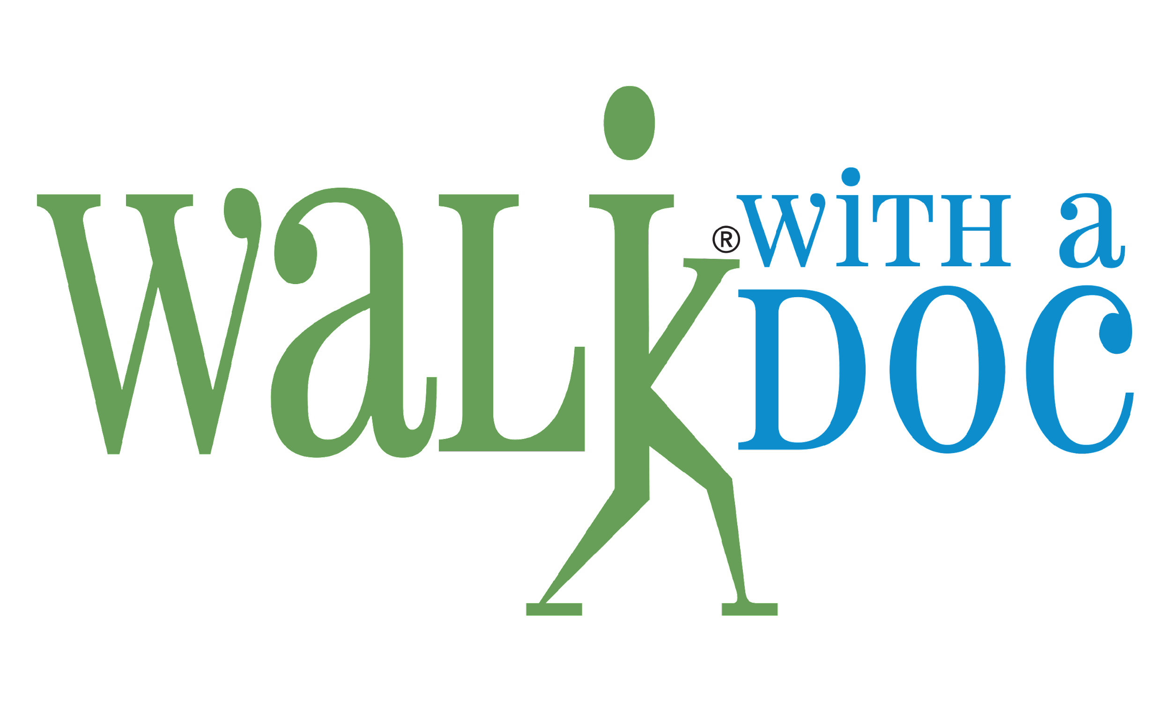

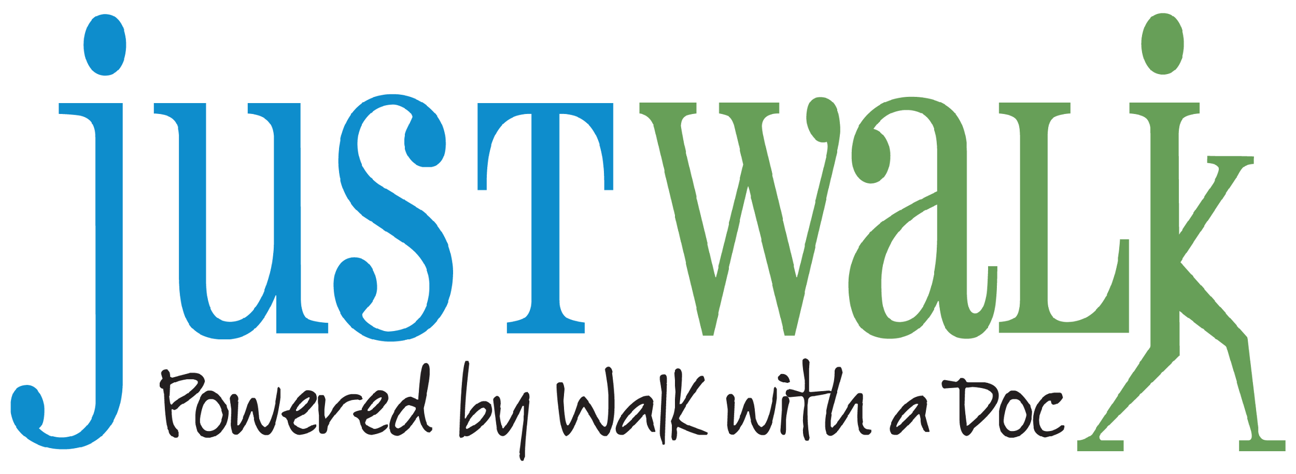

B) Word marks without stylization

Walk with a Doc

Just Walk! Powered by Walk with a Doc

EXHIBIT B

GENERAL TERMS AND CONDITIONS

- License and Reservation of Rights.
  - Trademark Guidelines. In its use of the Marks, the Company will comply with any trademark usage guidelines that Just Walk may communicate to the Company from time to time. The Company will provide Just Walk with copies of any materials bearing any of the Marks as requested by Just Walk from time to time. If the Company’s use of any of the Marks, or if any material bearing such Marks, does not comply with the then-current trademark usage policies provided in writing by Just Walk, the Company will promptly remedy such deficiencies upon receipt of written notice of such deficiencies from Just Walk. Other than the express licenses granted herein with respect to the Marks, nothing herein will grant to the Company any other right, title or interest in the Marks. All goodwill resulting from the Company’s use of the Marks will inure solely to Just Walk. The Company will not, at any time during or after this Agreement, register, attempt to register, claim any interest in, contest the use of, or otherwise adversely affect the validity of any of the Marks (including, without limitation, any act or assistance to any act, which may infringe or lead to the infringement of any such Marks). Except as set forth in this Agreement, the Company may not use any trademarks or logos other than the Marks in conjunction with the Walking Program without the prior written approval of Just Walk. The Company further agrees not to use or register the Marks as part of any trade name, corporate name, business name or domain name.
  - Copyright Rights. All artwork, designs, reproductions, and derivative works thereof that are created by the Company and which include or are derived from the Marks or materials included in the Toolkit are, for copyright purposes, works made for hire for Just Walk. In no event will any works be considered a joint work. If any work does not qualify as a work made for hire, then the Company hereby assigns to Just Walk all rights to such work, including, but not limited to, all copyright rights and other intellectual property rights.
  - Reservation of Rights. The parties acknowledge and agree that, except for the rights and licenses expressly granted by Just Walk to the Company under this Agreement, Just Walk will retain all right, title and interest in and to its products, services, Marks, and all content, information and other materials on its website or contained in the Toolkit, and nothing contained in this Agreement will be construed as conferring upon the Company, by implication, operation of law or otherwise, any other license or other right.
  - No Challenge. The Company agrees: (i) never to challenge the validity or ownership of the Marks or any application for registration thereof, or any trademark registrations thereof, in any country or jurisdiction; (ii) never to contest the fact that the Company’s rights under this Agreement are solely those of a licensee and terminate upon termination of this Agreement; (iii) never to make any claim to ownership in the Marks by virtue of its activities under this Agreement or otherwise; (iv) never to use any other trademark, brand name, trade name, symbol, logo, design or the like which is confusingly similar to the Marks; and (v) never to use, promote, advertise, display or otherwise commercialize the Marks or any material utilizing or reproducing the Marks or take any other action in a manner that will adversely affect any rights of ownership of Just Walk therein or in a manner that would affect the validity of the Marks or would dilute or depreciate its value or its reputation.
- Warranties; Limitation of Liability.
  - Warranties. Each party represents and warrants to the other that (a) it has the full power to enter into this Agreement and to perform its obligations hereunder, (b) this Agreement constitutes a legal, valid and binding obligation of such party, enforceable against such party in accordance with its terms, and (c) this Agreement does not contravene, violate or conflict with any other agreement of such party.
  - Disclaimer. EXCEPT AS SPECIFICALLY PROVIDED IN THIS AGREEMENT, JUST WALK DOES NOT MAKE, AND EXPRESSLY DISCLAIMS, ANY REPRESENTATIONS OR WARRANTIES IN CONNECTION WITH THIS AGREEMENT, WHETHER EXPRESS, IMPLIED, STATUTORY OR OTHERWISE, INCLUDING, WITHOUT LIMITATION, WARRANTIES OF MERCHANTABILITY, FITNESS FOR A PARTICULAR PURPOSE, NON-INFRINGEMENT OF THIRD PARTY RIGHTS, TITLE, ANY WARRANTIES ARISING OUT OF A COURSE OF PERFORMANCE, DEALING OR TRADE USAGE, AND THEIR EQUIVALENTS UNDER THE LAWS OF ANY JURISDICTION.
  - Limitation of Liability. EXCEPT FOR THE PARTIES’ OBLIGATIONS PURSUANT TO SECTION 4, NEITHER PARTY SHALL BE LIABLE TO THE OTHER PARTY FOR ANY SPECIAL, CONSEQUENTIAL, PUNITIVE, INCIDENTAL, OR INDIRECT DAMAGES ARISING OUT OF OR IN CONNECTION WITH THIS AGREEMENT, HOWEVER CAUSED AND BASED ON ANY THEORY OF LIABILITY, ARISING OUT OF THIS AGREEMENT, WHETHER OR NOT SUCH PARTY HAS BEEN ADVISED OF THE POSSIBILITY OF SUCH DAMAGE, AND NOTWITHSTANDING ANY FAILURE OF ESSENTIAL PURPOSE OF ANY LIMITED REMEDY.
- No Agency; No Disparagement. Notwithstanding anything in this Agreement, neither party will make any claims, representations or warranties on behalf of the other party or bind the other party, and neither party is authorized to do so by this Agreement. The relationship between the parties will be that of independent contractors. Nothing contained herein will be construed to imply a joint venture, principal or agent relationship, or other joint relationship, and neither party will have the right, power or authority to bind or create any obligation, express or implied, on behalf of the other party. During the term of this Agreement, the Company shall not make any public statements disparaging the Marks, products or services.
- Indemnification. Except as expressly set forth in this Section 4, neither party shall have any obligations to indemnify the other party. The Company agrees to indemnify and hold harmless Just Walk from and against any and all claims, damages, liabilities, losses, judgments, costs, and attorneys’ fees arising directly out of, or relating to: (a) the Company’s gross negligence or willful misconduct in engaging in the marketing and promotional activities described in this Agreement, (b) any statements made by Company during the term of this Agreement disparaging the Marks, products or services of Just Walk, whether or not such statements are true, and (c) any claim against Just Walk related to or arising out of alleged exposure to COVID-19 at a Company event. Notwithstanding the foregoing, Just Walk shall have the right, in its absolute discretion and at its sole cost, to employ attorneys of its own choice and to institute or defend any claim for which Just Walk has a right to be indemnified.
- Term and Termination.
  - Term. The term (“Term”) shall commence on the Effective Date and shall continue for one year, unless earlier terminated pursuant to this Section 5.
  - Termination. Either party without cause may terminate this Agreement upon thirty (30) days prior written notice to the other party.
  - Survival. Sections 1.2, 1.3, 2.2, 2.3, 3, 4, 5.3, 6 will survive any expiration or termination of this Agreement. Notwithstanding the foregoing, the expiration or termination of this Agreement will not relieve the parties of any liability or obligation that accrued prior to such expiration or termination. Upon the expiration or termination of this Agreement, the Company will immediately cease the display and use of the Marks and the marketing and promotional activities as described in this Agreement.
- General.
  - Confidential Information. Each party acknowledge and agree that in connection with this Agreement each will be exposed to information relating to the other and the other’s businesses and agents that is confidential in nature and/or proprietary, including trade secrets. During the term of this Agreement and thereafter each (A) shall treat as confidential any and all information disclosed or made known to it by the other (whether through actual disclosure or observance) and all other information relating to the other and its agents and business; (B) shall not publish or disclose such information in any manner or fashion to any third party without the other’s prior written consent; and (C) shall not use such information for any purpose except in connection with performing the obligations hereunder. The confidential information and trade secrets of each party include, without limitation, information relating to each party’s respective business methodologies, marketing, contacts, relations, finances and operations (including, without limitation, cost and pricing figures and statistics, business projections, marketing strategies and plans) not generally known to the public. The foregoing obligations do not apply to any information that is or becomes generally known to the public apart from disclosure by a party or its affiliates or its or their present or former employees or agents, or which was known to or used by a party or its affiliates in the conduct of its business operations prior to the Effective Date. At the request of a party from time to time, the other party(ies) shall cause its (or its affiliates’) employees to execute a confidentiality agreement in a mutually agreed upon form. Upon termination of this Agreement, each party and its affiliates and its or their employees shall return to the other party(ies) all records, data, notes, reports, material and other documentation, and all reproductions of the same, relating to such other party(ies).
  - Governing Law; Venue. This Agreement is to be construed in accordance with and governed by the internal laws of the State of Ohio without giving effect to any choice of law rule that would cause the application of the laws of any jurisdiction other than the internal laws of the State of Ohio to the rights and duties of the parties. Each party hereby irrevocably consents to the jurisdiction and venue of the state and federal courts located in Franklin County, Ohio in connection with any claim, action, suit, or proceeding relating to this Agreement and agrees that all suits or proceedings relating to this Agreement shall be brought only in such courts, provided that either party may seek injunctive, equitable or similar relief from any court of competent jurisdiction.
  - Waiver; Severability. No waiver of a party’s rights shall be effective unless such waiver is in writing signed by the waiving party. If any provision of this Agreement or the application of such provision to any person or circumstance shall be held invalid, illegal, against public policy or is otherwise unenforceable, the remainder of this Agreement or the application of such provision to persons or circumstances other than those to which it is held invalid shall not be affected thereby.
  - Assignment. The Company may not assign its rights or obligations under this Agreement without the prior written consent of Just Walk, which may be granted or withheld in Just Walk’s sole discretion. Just Walk shall have a complete and unrestricted right to transfer its rights and interests under this Agreement.
  - Notices. Any notice required or permitted to be given by either party under this Agreement shall be in writing and sent to each party at its address or facsimile number set forth in the first paragraph of this Agreement, or such new address or facsimile number as may from time to time be supplied by the parties hereto in accordance with this Section 6.5.
  - Captions; Amendment. The captions or headings of the Sections of this Agreement are for reference only and are not to be construed in any way as part of this Agreement. Any modification or amendment of any provision of this Agreement will be effective only if in writing and signed by an authorized representative of both parties.
  - Counterparts. This Agreement may be executed in one or more counterparts, each of which shall constitute an original, but all of which together shall constitute one instrument.
  - Policies and Procedures. The Company will establish and adhere to appropriate health and safety policies and procedures for its Walking Program, including ensuring that participants and volunteers sign in and agree to be bound by the Waiver and Release of Liability and that measures to mitigate risk of transmission of communicable diseases (such as COVID-19) among participants and volunteers are implemented. These policies and procedures should be consistent with Just Walk’s policies and procedures and, with respect to COVID-19, shall adhere to all recommendations and guidance from the Centers for Disease Control and Prevention and applicable local and state health authorities.

