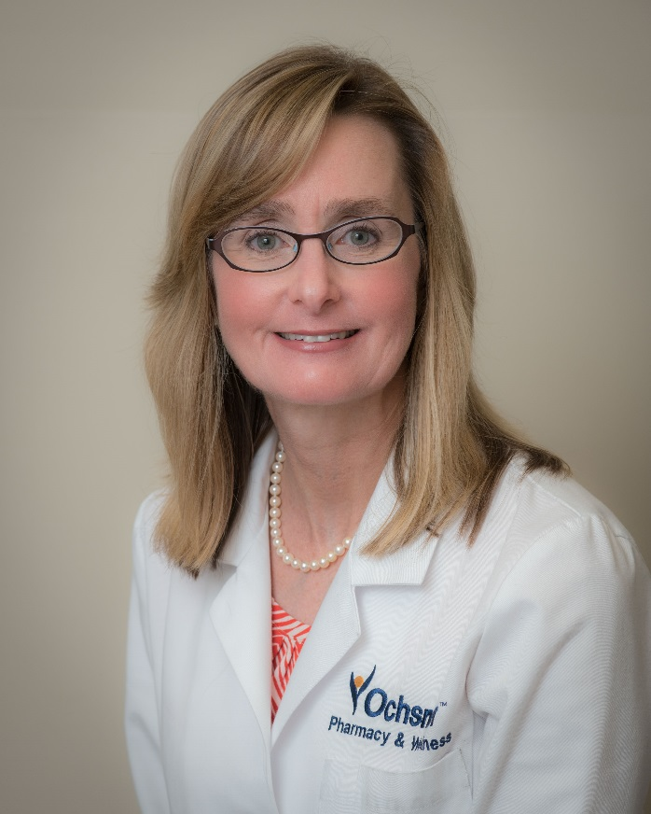
Cynthia Harper earned her pharmacy degree from Northeast Louisiana University. She worked for a chain drugstore for 27 years. During the 26 years as a registered pharmacist she became an APhA certified immunizer and a provider for CLIA waived testing. She performed comprehensive medication reviews as outlined by the Outcomes platform and was also a trained provider for the Mirixa platform. She is currently Retail Pharmacy Manager of the Covington Ochsner Pharmacy and Wellness.
She maintains a good rapport and collaborates effectively with the physicians. Her main goal is to always concentrate and focus on the positive well-being, health, and safety of her patients.

