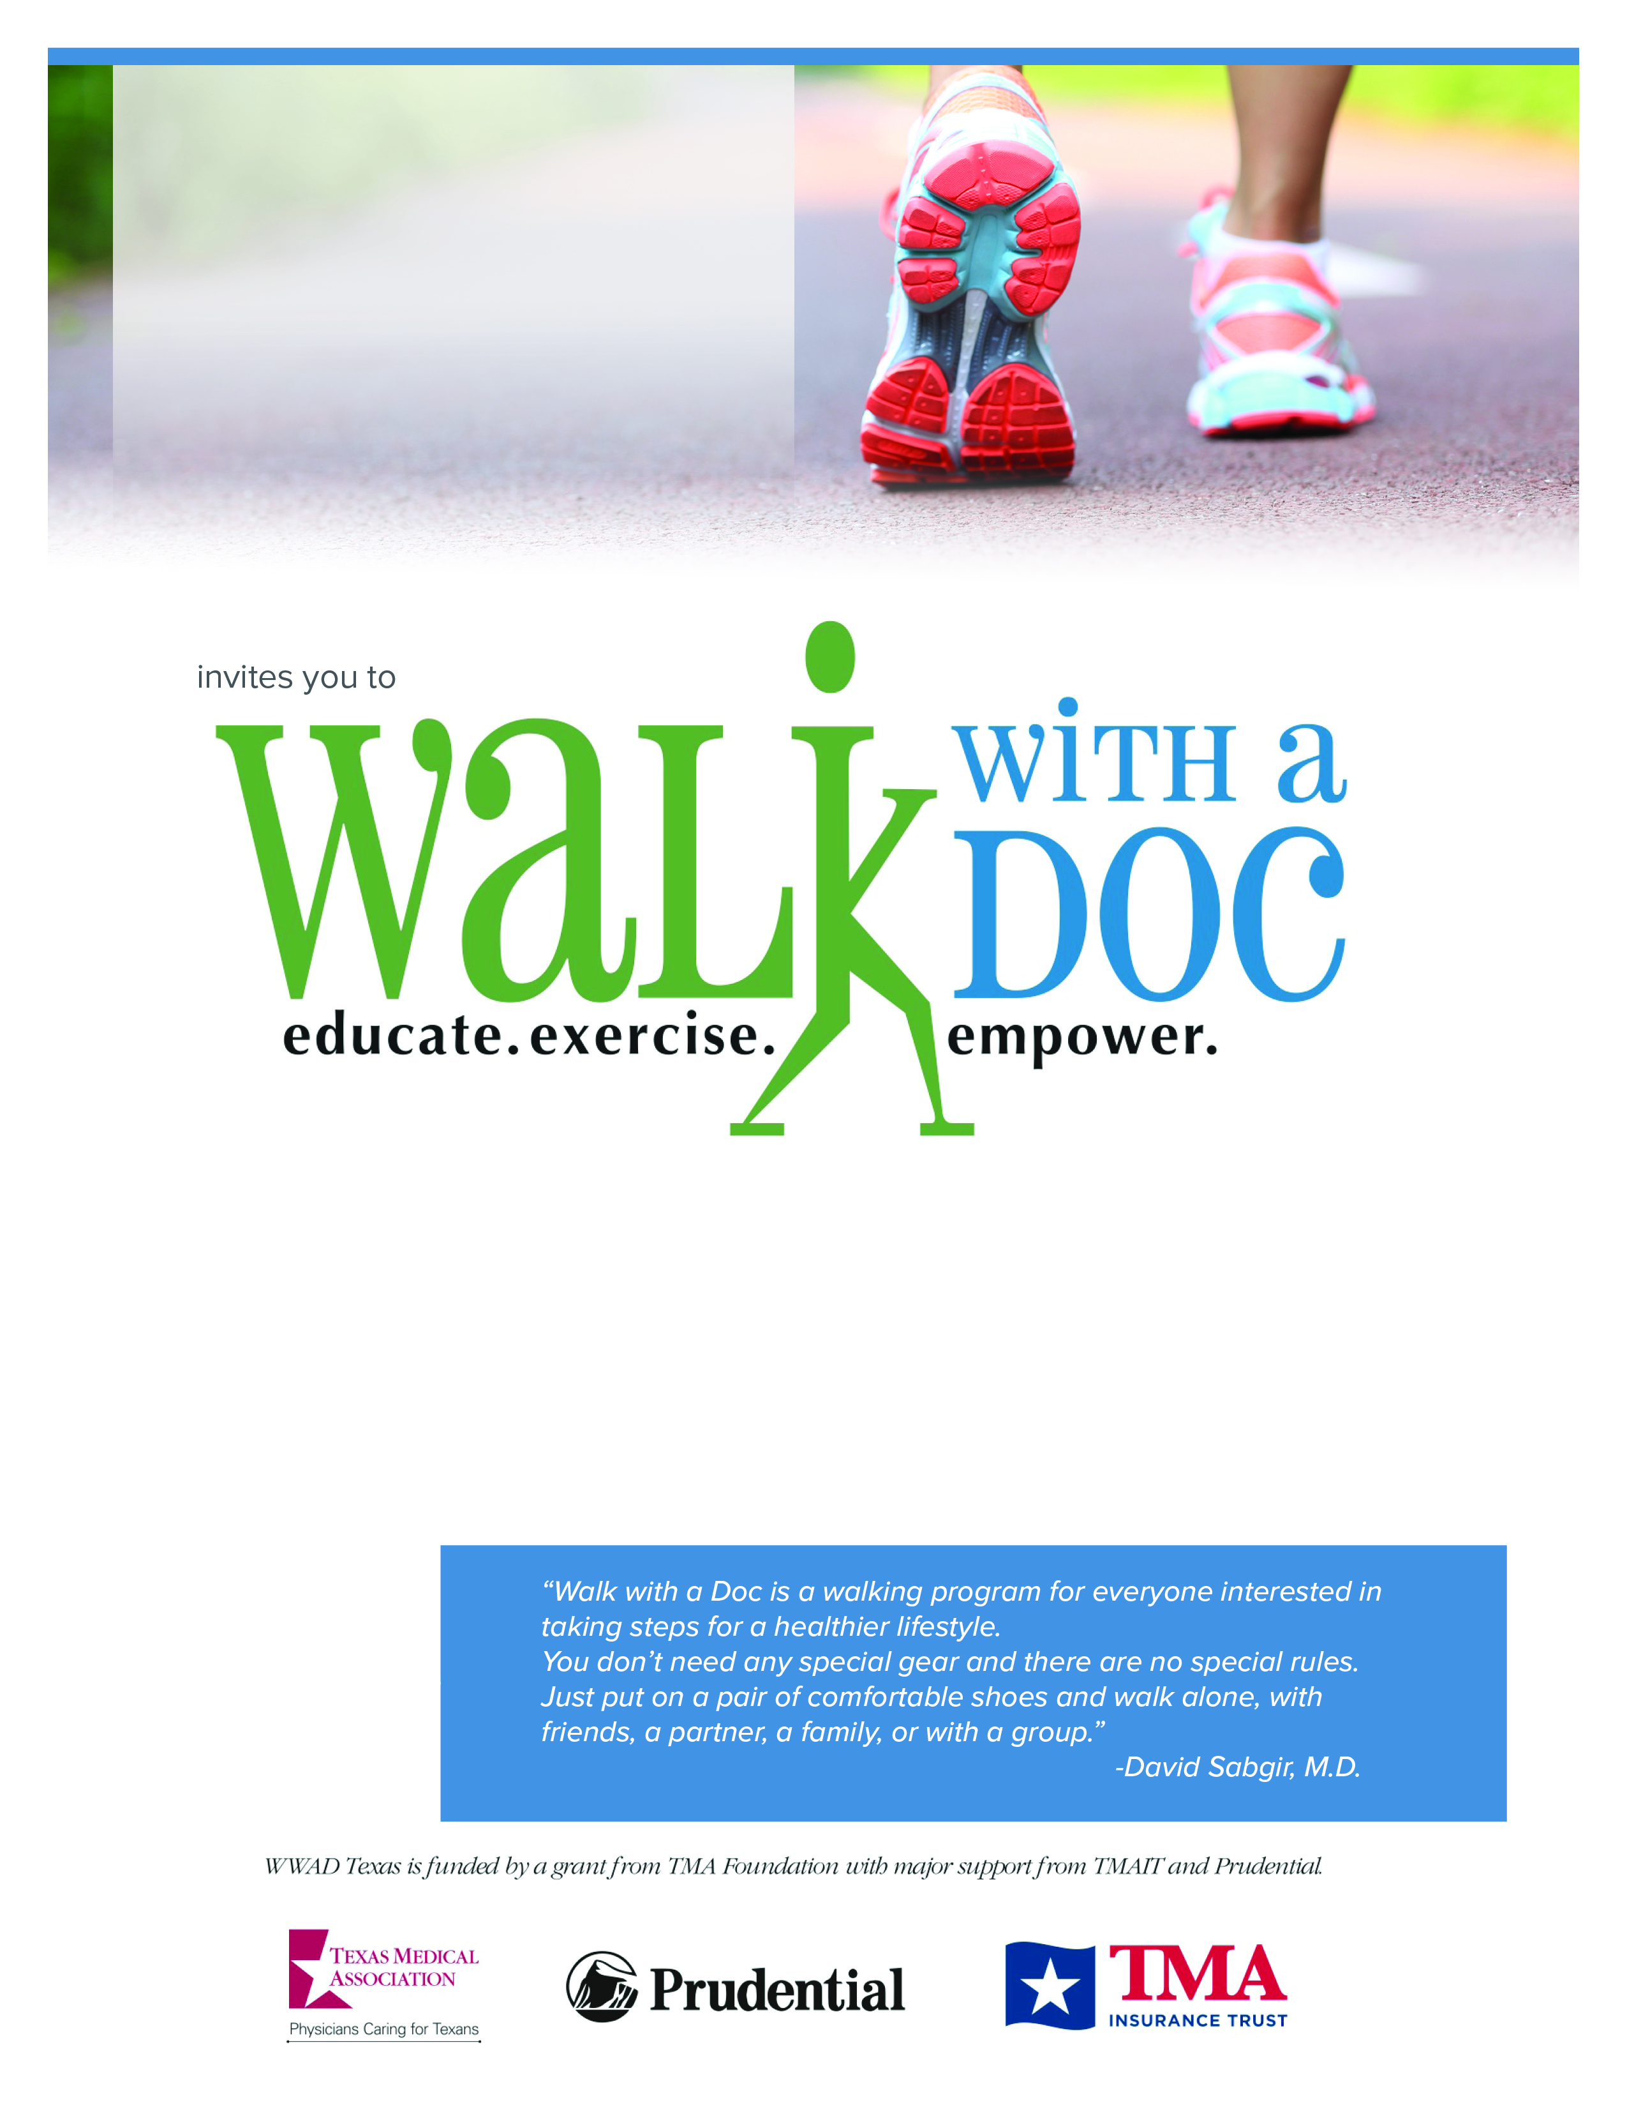

**Sat. January 1, 2020**

**10:00 – 11:00 AM**

**Central Park**

**(222 W. Park St. New York)**

**Questions?**

Email Address

Phone Number

[Name or logo here]

Have fun and join us for Walk with a Doc. You’ll take a few minutes to learn about a current health topic, then spend the rest of the hour enjoying a healthy walk at your own pace and distance. It’s a great way to get some exercise, learn about health, and meet new friends. The event is **free** and open to everyone, so please feel free to bring family or friends!



**INSERT**

**PHOTO/**

**LOGO**

**HERE!**

We are a local chapter of an international program. Learn more at www.walkwithadoc.org.