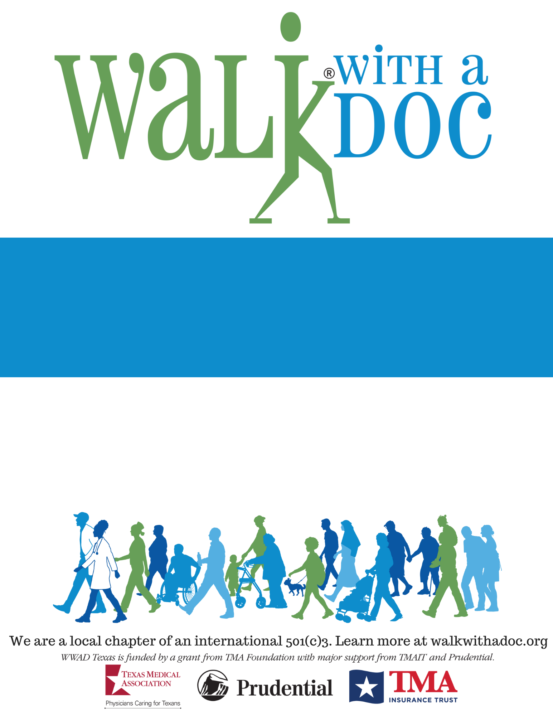

This doctor-led group is a fun and safe place to go for a walk, learn about health, and meet new friends.

The event is **FREE** and all are welcome!

Future walks will be held on the 1st Saturday of every month.

**Questions?** Phone Number | Email Address

**Your City**

**Saturday, January 1st 2018**

**10:00 – 11:00 AM**

**Central Park- 123 Main St. Manhattan, NY**

**(meet at the fountain)**