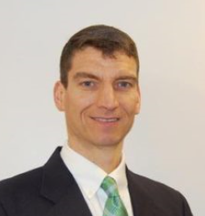

**192 Park Street, Springfield Hospital Campus**

For more information, contact Laura Jensen at the

Department of Lifestyle Medicine at Springfield Health Center

LJensen@springfieldmed.org

802-886-8928

Have fun and join us for a healthy walk.

You’ll take a few minutes to learn about a current health topic; then spend the rest of the hour enjoying a healthy walk and conversation with a doc.

It’s a great way to get out, get active, and enjoy good conversation.

Walk your own pace and distance.

See you on **August 27th,** and bring a friend to this free community event!

**Tuesday, Aug. 27th**

**12:00 – 1:00pm**

**●**

Walk with Dr. Muller!

