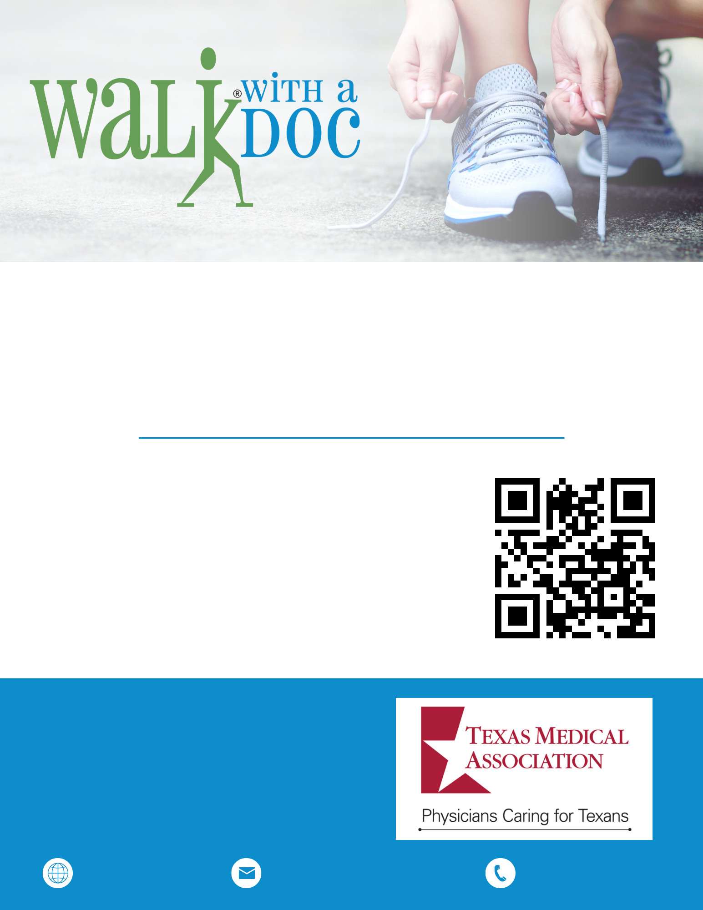


JOIN US FOR WALK WITH A DOC!
You’ll take a few minutes to learn about a current health topic, then spend the rest of the hour enjoying a healthy walk at your own pace and distance. It’s a great way to be active, learn about health, and meet new friends. The events are free and open to everyone!
walkwithadoc.org
contact@walkwithadoc.org
(614) 714-0407
1st SATURDAY OF EVERY
MONTH AT 9:00 AM
CENTRAL PARK
123 MAIN ST. DALLAS, TX

