
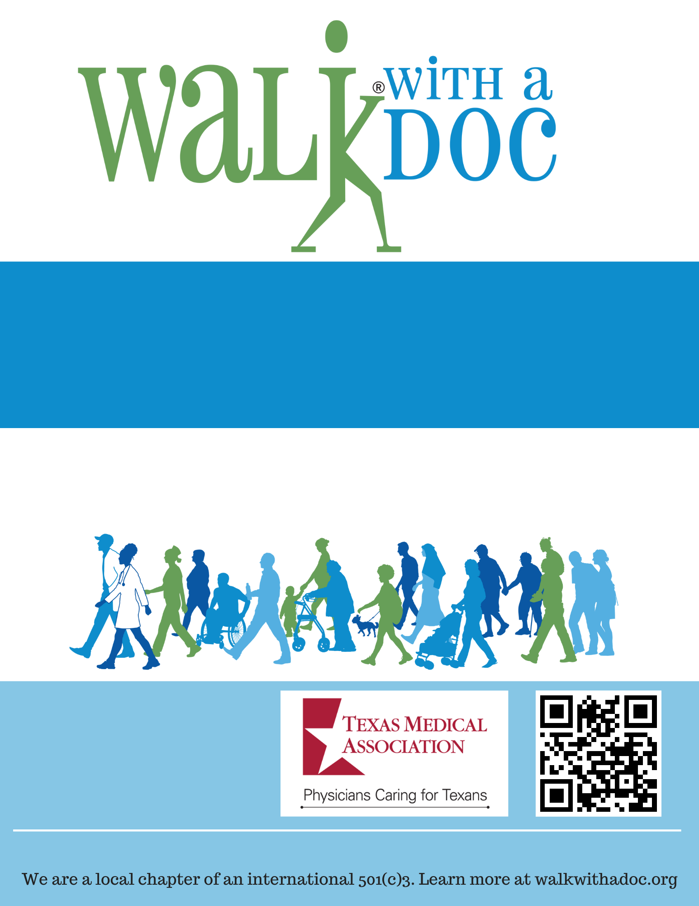
Questions? Email contact@walkwithadoc.org or call (614) 714-0407
Join us on the 1st Saturday of every month for Walk with a Doc! This doctor-led group is a fun and safe place to go for a walk, learn about health, and meet new friends. The events are FREE and all are welcome!
Saturday, January 1, 2023
10:00 – 11:00 AM
Central Park- 123 Main St. Dallas, TX
(meet at the fountain)
Your City

