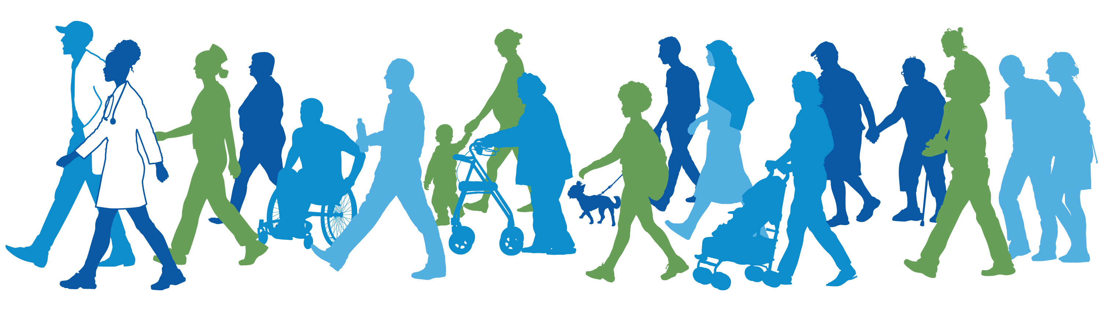

This doctor-led walking event is a fun and safe place to go for a walk, learn about health, and meet new friends.

The event is **FREE** and all are welcome!

**Questions? Email: example@email.com | Phone: 555-555-5555**

**Saturday, September 3, 2022**

**10:00 – 11:00 AM**

**Central Park- 123 Main St. Pittsburgh, PA**

**(meet at the fountain)**