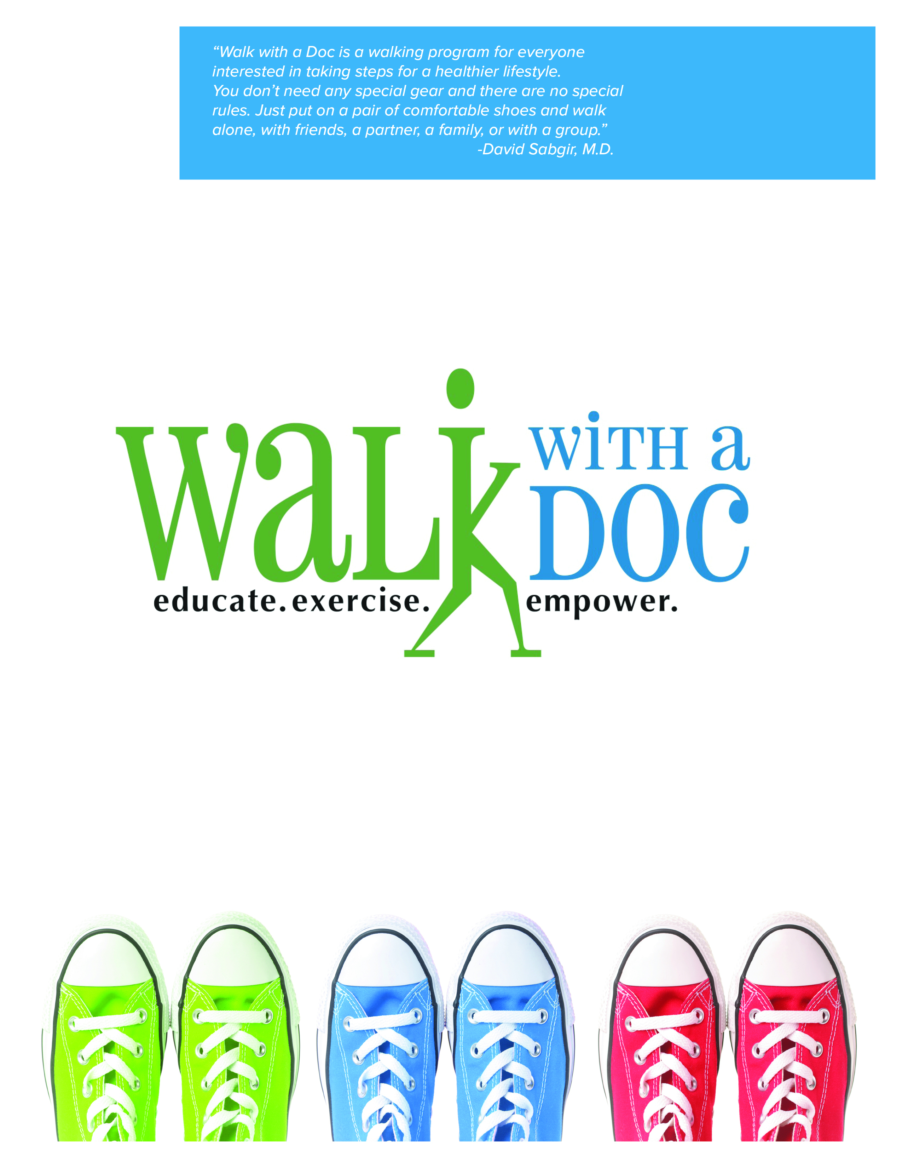

**The Walk/Bike/Run will be followed by a Community Block Party! For more information on all of the Family 101 Events please go to this website** [**http://www.nbccdc.org/2019-family-101.html**](http://www.nbccdc.org/2019-family-101.html)

Have fun and join us for a healthy walk. All ages welcome and it’s FREE!!!

You’ll take a few minutes to learn about a current health topic; then spend the rest of the hour enjoying a healthy walk and conversation with healthcare professionals.

**University of Kansas Medical Center in partnership with the NBCCDC as part of the 6th Annual Family 101 5K Walk/Bike/Run invites you to**

**Saturday May 18th 2016**

**9:00am – 10:00am**

**●**

**Jersey Creek Park – 745 Walker Ave. – Kansas City, KS**