Month | Date | Location | Time | Theme | Guest Speaker
March | 3/6/2019 | Boggy Creek Greenbelt | 8:45am – 9:45am | Osteoporosis | Dr. Chiluvuri
April | 4/3/2019 | Boggy Creek Greenbelt | 8:45am – 9:45am | Stress Awareness Month | Mark Milligan, PT
May | 5/1/2019 | Boggy Creek Greenbelt | 8:45am – 9:45am | Fertility or Menopausal Symptoms | Dr. Moghadam
June | 6/5/2019 | Boggy Creek Greenbelt | 8:45am – 9:45am | Dementia | Dr. Chiluvuri
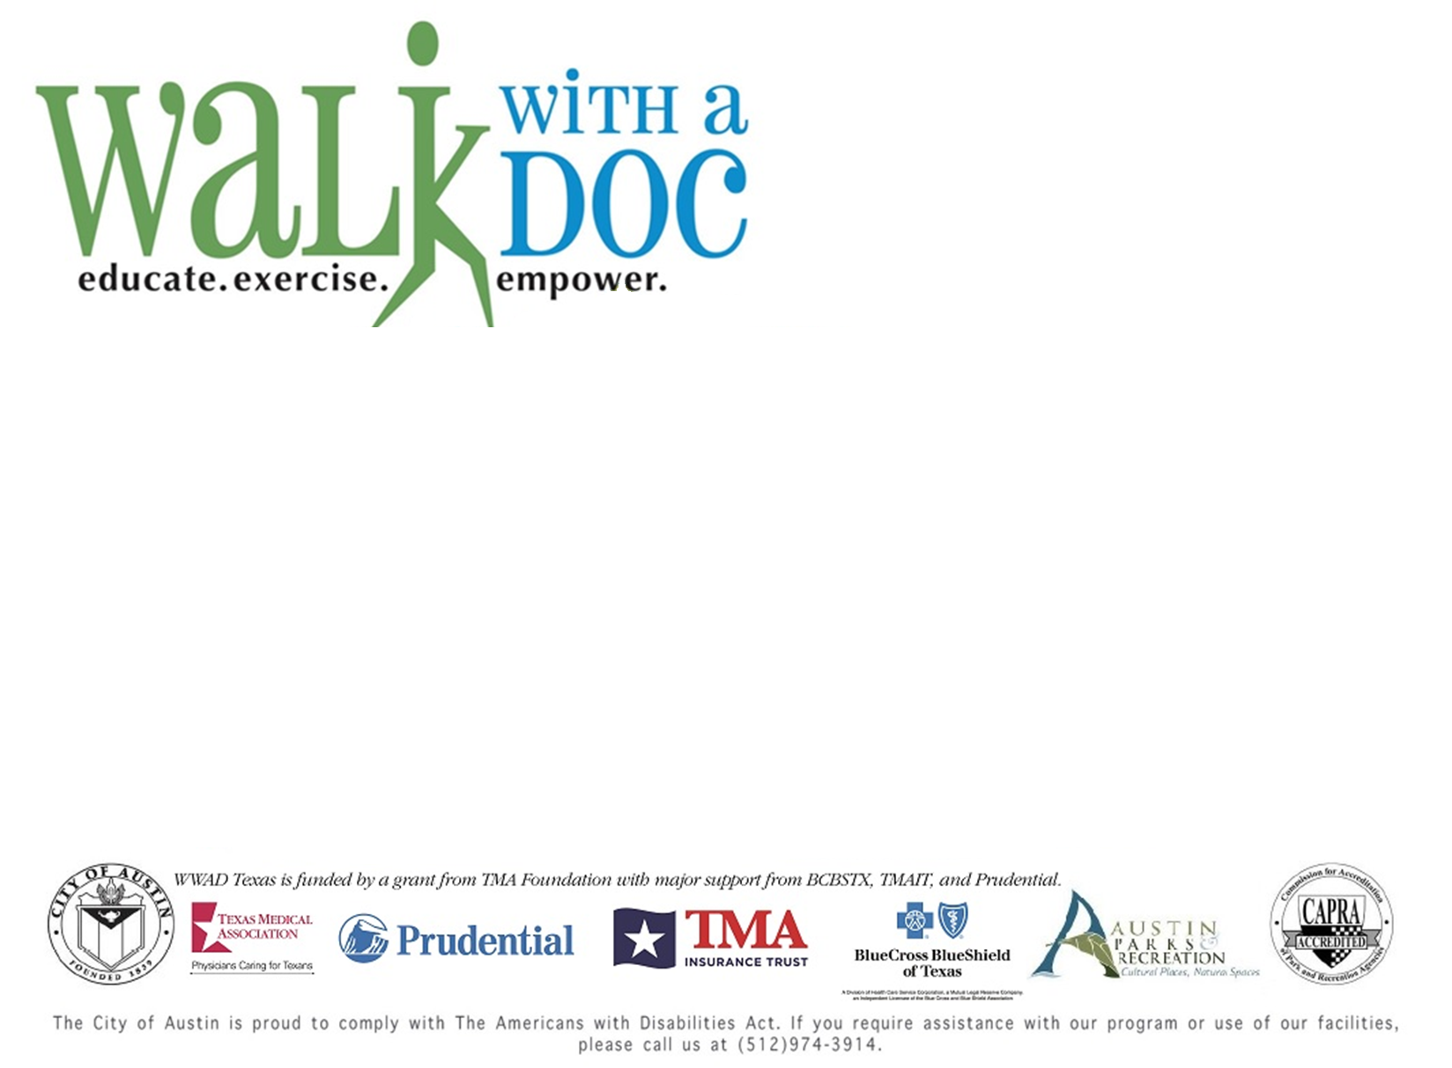
8:30am – Free blood pressure and cholesterol screenings 9:00am – Guest Speaker talks 9:05am – Walk the trail
Walk with a Doc (WWAD) is a monthly health event held by the Parks and Recreation Department. WWAD connects health professionals with community members for short presentations on different health topics each month at a local park or trailhead.
2019 Schedule

