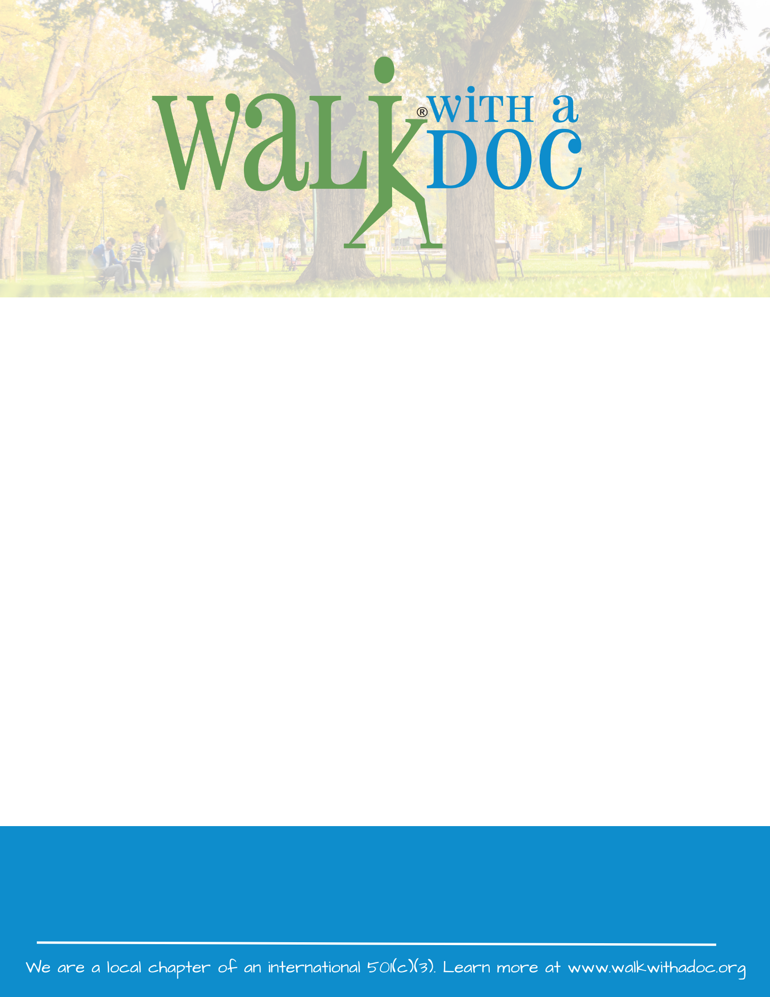

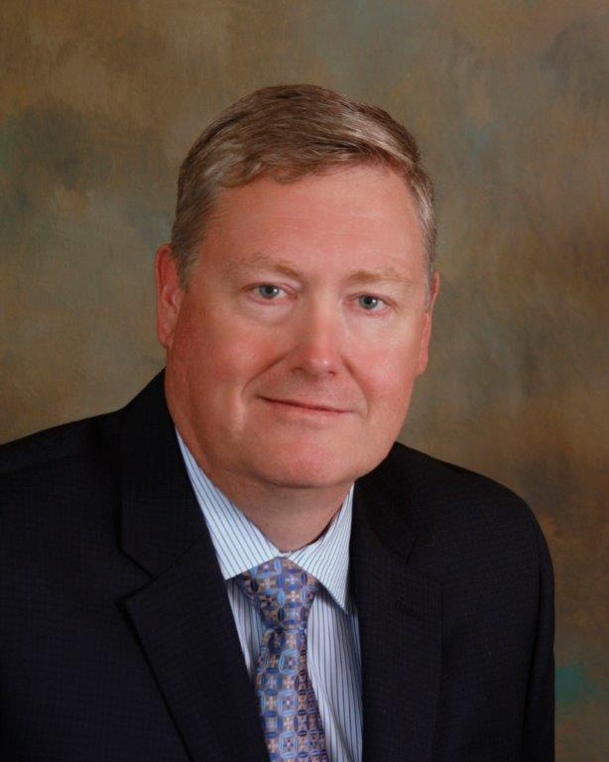

* **Saturday June 25th**
* 9:00 - 10:00 AM
* Marion F Clawson Memorial Park 1055 Old York Road, Ringoes, NJ 08551

**Questions?  
(908) 788-1710 x250  
bf@hunterdoncardiovascular.com**

Join us for Walk with a Doc! This doctor-led group is a fun and safe place to go for a walk, learn about health, and meet new friends. The event is **FREE** and all are welcome! Learn more at www.walkwithadoc.org