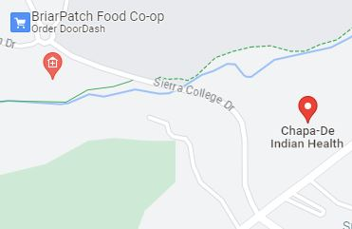

**Jan. 17th July 17th**

**Feb 21st Aug 21st**

**March 20th Sept 18th**

**April 17th Oct 16th**

**May 15th Nov 20th**

**June 19th Dec 18th**

**Third Wednesday of Every Month**

**Litton Trailhead**

**Sierra College Dr.**

**7:30 – 8:30 AM**

**2024 Schedule**

contact@walkwithadoc.org

614-714-0407

www.walkwithadoc.org