COME AND JOIN US!
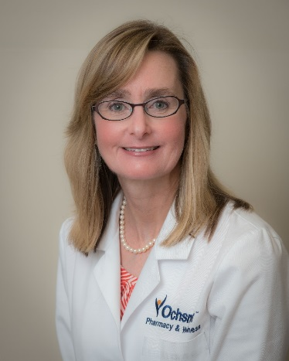

Ochsner North Shore Covington
will be hosting a "Walk With A Doc" walk
Nov 2, 2019
Registration 8:00 - 8:30AM
WALK TIME 8:30 AM - 9:30 AM
Ochsner Covington Campus
Walk with a Doc: Cynthia Harper RPh
Topic for Walk: Pre-diabetic Syndrome and Diabetes

